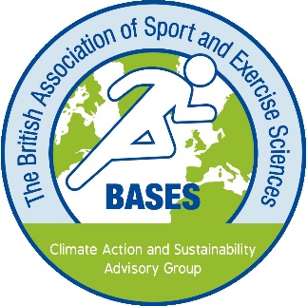
The BASES Climate Action and Sustainability Strategy
The BASES Climate Action and Sustainability Strategy aims to ensure our vision and mission are relevant to sport and exercise science, collaboratively progressed through interdisciplinary practices and informed by the scientific evidence. We endeavour to ensure our Climate Action and Sustainability Strategy is research-informed, impactful across BASES as an organisation and the sport and exercise science sector and focuses on real change. We will be guided by input from our members and key stakeholders, to utilise their ideas and experiences.
There are three strategic objectives which include a value proposition for membership, professional standards, partnerships and advocacy, financial sustainability, and governance. Each strategic objective has distinct workstreams, which include several milestones, deliverables and/or quantifiable measures:
Climate Action and Sustainability Strategic Objectives:
- Promote greater sustainability and responsibility practices in sport and exercise science.
- Within this objective, we will continue to review all BASES’ accreditation programmes (laboratory, individual and course endorsement), to ensure climate action and sustainability have been considered across the curriculum, laboratory use and professional/consultancy practice. BASES will also continue to re-assess our events and publications, to address approaches that support reducing emissions and wastage.

- Present and disseminate research-informed education and guiding principles associated with sport and exercise climate action.
- Within this objective, we will share climate action and sustainability resources for sport and exercise science, which will be outlined to all new and existing BASES’ accredited and/or endorsed laboratories, courses, members, supervisors, examiner/reviewers, and key stakeholders. Our public and member webpages will include updates, information, resources, and suggested reading to support climate action and sustainability in sport and exercise science. BASES will also publish reports, organise webinars and provide workshops for our members which will be aligned to sport and exercise science, climate action and sustainability.

- Quantify then reduce BASES’ organisational and associated activities’ carbon footprint and greenhouse gas emissions.
- Within this objective, we will continue to gather information and audit our working practices and activities as an organisation. This will be used to calculate our climate footprint and greenhouse gas (GHG) emissions, which is necessary to continually evaluate the overall climate impact of BASES, and to understand which activities contribute most. We will continue to refine our science-based target of carbon neutrality, minimise our GHG emissions, provide annual reports on our progress and strive to meet an annual reduction in our footprint.
The success of our Climate Action and Sustainability Strategy is dependant upon us, your association, but we will also be advocating that our members engage and volunteer across the breadth of our proposed strategies, guiding principles and activities. The BASES Board is grateful to the Climate Action and Sustainability Advisory Group (CASAG) and also those members, societies and businesses who will support our strategy in the face of the ongoing climate emergency,
Thank you.
BASES Board and the Climate Action and Sustainability Advisory Group (CASAG)

