Action Plan (final)

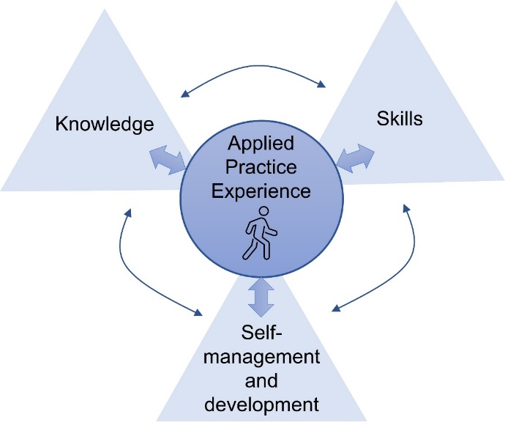
Candidate name:
Figure 2 from Candidate Handbook

The HCPC provides standards for CPD, and outlines that “all registrants should undertake CPD on a continuing basis, made up of activities that enhance their practice and learning”.
Please use the space below to outline how you plan to continue to develop your experience, skills, self-development and management and knowledge competencies when you complete SEPAR (as outlined in Figure 2, experience comes first since this links everything else together).
Please be as specific as possible, and refer to SEPAR competencies as appropriate within your plans.

Experience (100-250 words)
Skills (100-250 words)
Self-management and development (100-250 words)
Knowledge (100-250 words)

